Membership Meeting Minutes
Aurora Highlands Civic Association
March 11, 2026, at Aurora Hills Center and via Zoom

Opening of Meeting
President Stacy Meyer opened the meeting at 7:02 p.m. with a welcome to the membership and an overview of the agenda.
Minutes Approval
The draft minutes for the February 2026 regular meeting were approved.
Presentation of New Potomac Yard Arlington Civic Association
Dorian Adeyemi briefed the members on the new Potomac Yard Arlington Civic Association (PYACA) which is forming in the southern end of Crystal City where there has been no association. The group has recently reached 20 members and as part of their petition process for Arlington County Civic Federation membership need support of the adjoining neighborhoods. The issues they will deal with include train noise, loss of trees, traffic, the refit of the former Harris Teeter site and the development of the Lidl parking lot. The borders for PYACA will abut the AHCA border in the east, see map below. The group consensus was to support the new group and send a letter to CivFed.
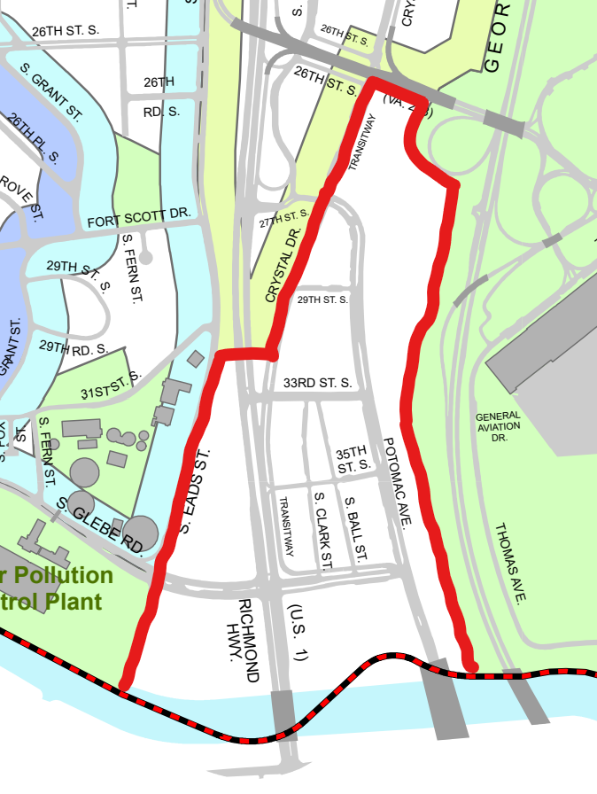
Discussion Items
- Library Centennial – New branch librarian Megan Wianecki spoke about the Aurora Hills library centennial celebration scheduled for Saturday, May 30 and encouraged participation.
- CC2DCA – Kyle Kling gave a brief overview of the current status of the pedestrian bridge from Crystal City to National Airport. The preliminary design is open for public comments, which are due by March 29. Project details and the survey are at this link.
- Local Historic District Draft Report – The County staff report has been published, link, and concludes that the Nellie Custis School does not merit historic protection. The group discussed the flaws in the analysis, the lack of adherence to the objective standards set out in the zoning ordinance, and its reliance on an erroneous requirement for historic integrity. Stacy stressed the need to write letters and for the neighborhood to come out for the March 18 meeting of the Historic Affairs and Landmark Review Board (link for meeting details).
- Faith in Housing – Nick Giacobbe discussed Senate Bill 388 and House Bill 1279 which would permit by right development on land owned by tax exempt religious organizations or non-profit institutions. They are permitted up to 45 feet or the tallest existing building within 500 feet of the property line. This legislation could have a significant impact on the five churches on 23rd Street. Stacy urged everyone to contact our members of the delegation in Richmond and press for passage of a reenactment clause.
- Westpost – Alex Chakrin briefed on a request by Federal Realty to omit the site plan condition for Westpost that requires a drug store since Walgreens is not renewing their lease. At the same time Federal Realty wants to omit site plan condition 52 completely, which requires a grocery store. Alex will meet with Federal in the coming days and they will brief at the April AHCA meeting. According to the staff, the proposal will not go to the County Board until June.
- X-TSA Headquarters – Nick briefed on a very recent proposal from JM Zell Partners to purchase the site from Brookfield Properties and do an adaptive reuse project on the existing buildings to create 637 apartments and add new retail construction along 12th Street South. More details to follow with this preliminary 4.1 application.
- Upcoming Meeting with Legislative Delegation – Dana Bres has been working to organize a meeting that will likely be held on April 9, if we can secure a meeting space.
- Membership – Carl Allen talked about some ways to increase our membership and then growing our leadership corps, noting that the best marketing starts with a great product. He would like to focus on groups we are not reaching right now through a series of seminars such as buying/selling homes, gardening, babysitting coops, pet sitting, accessory dwelling unit experiences, and various services. He also proposes a reduced membership fee for the first year in order to attract new members. This was a preliminary discussion but a lively start.
Meeting adjourned at 9:00 p.m.

Nicholas J. Giacobbe, Jr.
Recording Secretary

